TITLE PAGE

# ABSTRACT

Weka (Waikato Environment for Knowledge Analysis) is a comprehensive open-source suite of machine learning algorithms and data preprocessing tools. This project utilizes Weka's capabilities to analyze/classify/predict within a dataset.

This project addresses Weka's machine learning capabilities. The results demonstrate the effectiveness of Weka in achieving what the project set out to achieve.

"Weka's machine learning tools provide valuable insights in diverse fields. This project applies Weka to superficial data. The analysis aims to prove Weka's efficiency.

INTRODUCTION

Weka (Waikato Environment for Knowledge Analysis) is a powerful open-source suite of machine learning software tools developed at the University of Waikato, New Zealand. It offers a user-friendly graphical interface and a vast collection of algorithms, making it accessible for both experts and those new to the world of data analysis.

**What Makes Weka Stand Out**

* **Versatility:** Weka covers a wide range of data mining tasks, including:
  + **Preprocessing:** Cleaning, transforming, and preparing your data
  + **Classification:** Building models to predict categories (e.g., spam vs. non-spam emails)
  + **Regression:** Modeling relationships between variables to predict continuous values (e.g., stock prices)
  + **Clustering:** Identifying natural groupings within data
  + **Association Rule Mining:** Uncovering relationships between items or attributes (e.g., "Customers who bought X also bought Y")
  + **Visualization:** Exploring data patterns and relationships graphically
* **Accessibility:** Weka's graphical interface eliminates the need for extensive programming knowledge. Users can easily load data, experiment with different algorithms, and evaluate their results.
* **Extensibility:** Weka can be extended through plugins and its Java-based architecture allows for integration with other tools.

**Where Weka Shines**

* **Research and Education:** Weka is widely used in academic settings for teaching machine learning concepts and conducting research.
* **Rapid Prototyping:** Its ease of use makes it ideal for quickly testing different machine learning approaches on a problem.
* **Real-World Applications:** Weka can be utilized in areas like business intelligence, healthcare, scientific analysis, and many more.

**Problem Statements**

* **Classification**
  + **Problem:** A medical dataset has patient symptoms and test results. Can we accurately predict the diagnosis of disease X?
  + **Problem:** Customer emails need to be filtered into categories (complaint, inquiry, general feedback). Can we build a model to automate this?
  + **Problem:** Large amounts of network traffic data need to be analyzed. Can we identify patterns that suggest malicious intrusions?
* **Regression**
  + **Problem:** Historical housing sales data is available. Can we predict future home prices within a specific area based on various features?
  + **Problem:** A manufacturing company seeks to optimize production. Can we model the relationship between various process variables and output quality?
  + **Problem:** Is it possible to predict customer lifetime value based on initial purchase behavior and demographics?
* **Clustering**
  + **Problem:** A marketing team has customer data. Can we identify natural customer segments based on demographics and purchasing habits?
  + **Problem:** Can we identify similar genetic sequences within a large biological dataset to aid in research?
  + **Problem:** A news organization has a large corpus of articles. Can we group them into clusters based on topic?
* **Association Rule Mining**
  + **Problem:** A supermarket wants to understand purchasing patterns. Can we uncover frequent item-set combinations to inform product placement and promotions?
  + **Problem:** A website tracks user browsing behavior. Can we find associations between pages visited to personalize recommendations?
  + **Problem:** Can we identify any commonalities in the symptoms reported by patients to potentially uncover new disease relationships?

AND MANY MORE......

LITERATURE SURVEY

Methodology

1.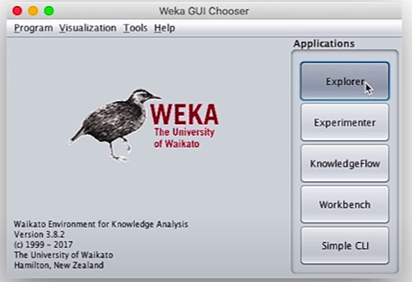

**Select the Weka Explorer:** This is the primary interface for most data analysis tasks in Weka. Click the "Explorer" button to proceed.

2.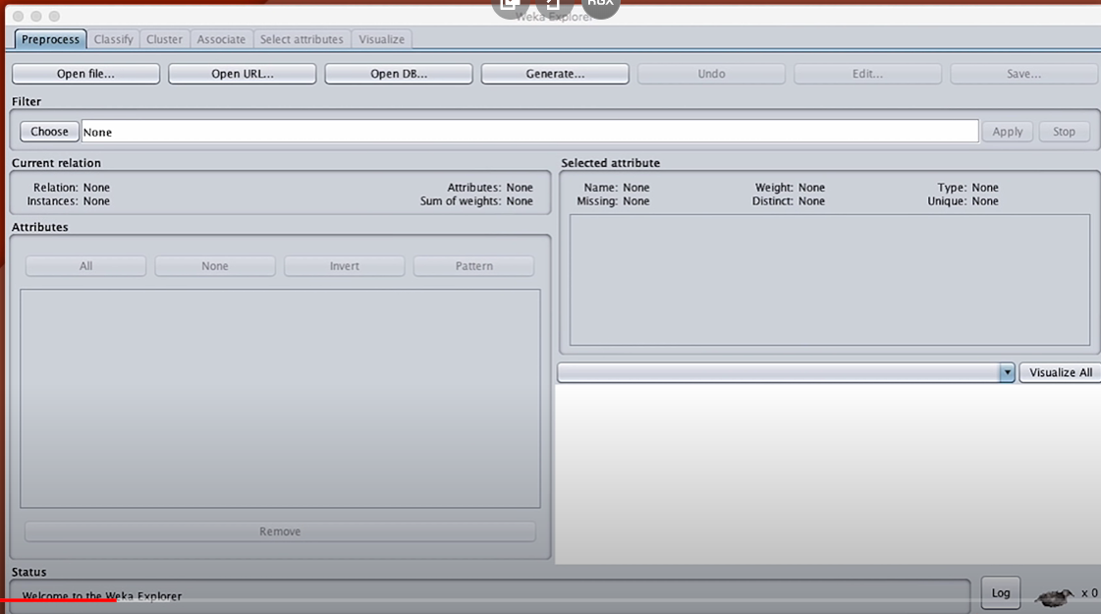**The Weka Explorer Interface: Overview**

* **Tabs:** You'll see several tabs at the top:
  + **Preprocess:** Data loading, cleaning, and transformation
  + **Classify:** Algorithm selection, model building, evaluation
  + **Cluster:** Clustering algorithms
  + **Associate:** Association rule mining
  + **Select attributes:** Feature selection techniques
  + **Visualize:** Graphical exploration of your data

3. **Loading Your Dataset**

1. **Preprocess Tab:** This is usually your starting point.
2. **Open file...** Under the "Open file..." button, locate your dataset file. Weka supports common formats like CSV, ARFF, etc. Click "Open".
3. **Inspect Your Data:**
   * The current dataset's name and characteristics will be displayed.
   * Click on individual attributes to see summary statistics and distributions.

